**Installing tcpdump**

tcpdump is a command-line utility that you can use to capture and inspect network traffic going to and from your system. It is the most commonly used tool among network administrators for troubleshooting network issues and security testing.

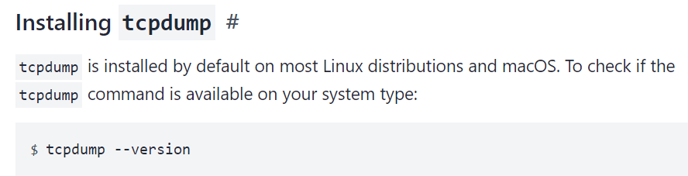

Output

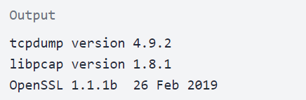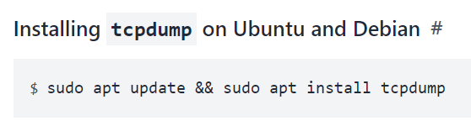

**Capturing Packets with tcpdump**

### Filtering by Protocol

To restrict the capture to a particular protocol, specify the protocol as a filter. For example, to capture only the UDP traffic, you would run:  
